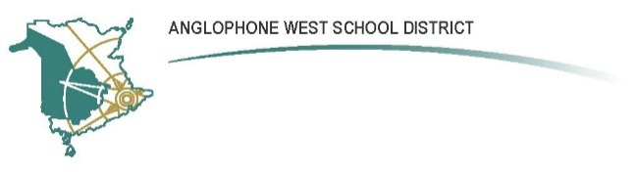Forest Hill School
548 Forest Hill Road, Fredericton, NB, E3B 4K6
Parent School Support Committee
Minutes
Date: February 27th, 2017 Time: 6:30 pm
Location: Forest Hill School
PSSC Members Present:  Dr. Naomi Lear, Chair  Louise Somerville, Vice Chair  Hannah Cusack, Teacher Rep.  N/A, Student Rep.  Others  Wendy Yano  Lacy Jacquard  Louise Somerville  Lisa Murphy  Naomi Lee  Dave Creber  Erin Bray  PSSC Members Regrets:  Amber Gilliss  Lisa Maher-Watson  Janice Mayer-Foster  Bronwyn Mulherin-Murphy | School/DEC Representation Present:  Paul Saad, Principal  Terry Pond, DEC  School/DEC Representation Regrets:
Call to Order: Approved by Naomi Lear, Lacy Jacquard (2nd) at 6:30 pm.

Approval of the Agenda: Dave Creeber

Approval of the Minutes from Previous Meeting: Erin Bray, Lacy Jacquard (2nd)

Business Arising from the Minutes:
NONE

New Business:
- Principal’s Report:
  - Positive Behaviour Intervention Systems (PBIS) – Paul provided an overview of PBIS and described initiatives being used at FH School to promote positive student behavior. These included the WIITS program as well as Flicker Awards.
  - Update on the potential for converting the existing student washrooms into all-gender washrooms. Paul provided a tour of the washrooms describing the approved options for converting the washrooms. Members came to a consensus that the best options were to board up existing urinals in one washroom and to go ahead with stalls in the other.
  - Paul announced that three classes of Early Immersion are registered at this point at FH School for Fall 2017. The implications of this on current teacher moral were discussed. It is assumed that some teachers will be displaced. The PSSC discussed ways we can support teachers during the remaining months of this school year.
  - ISBS beginning in September will also displace teachers throughout the district as a result of changes in school FTE.
- DEC Report:
- Sustainability study is being conducted on Kingsclear Consolidated School.
- Several other schools have been proposed for study. The DEC will be making recommendations on which of these will undergo 409’s.
- A tentative decision has been made that Grade 5 students from Liverpool, Montgomery and NMES wanting to enter Late Immersion will go to George Street Middle instead of BCMS.
Correspondence: None

Closing Comments: None

Date of Next Meeting: March 27th, 2017

Adjournment: Naomi Lee 7:32 pm

____________________ ____________________
PSSC Chair Date

Lisa Murphy March 25th, 2017
SSC Secretary Date

